Hive Solution

Q2) Store raw data into hdfs location

Ans)

* Hadoop fs –put /home/cloudera/dataset/sales_order_data.csv /datasets
* Hadoop fs – ls /datasets

Output -:

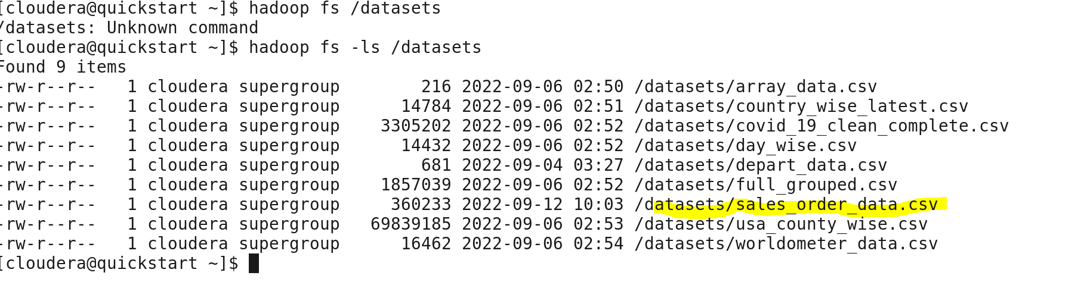

Q3) Create a internal hive table "sales_order_csv" which will store csv data sales_order_csv .. make sure to skip header row while creating table

ANS)

* Use hive_class_r1;
* create table sales_order_data_csv
* (
* order_number int,
* quantity_ordered int,
* price_each float,
* order_line_number int,
* sales float,
* status string,
* qtr_id int,
* month_id int,
* year_id int,
* product_line string,
* msrp int,
* product_line string,
* phone string,
* city string,
* state string,
* postal_code string,
* country string,
* territory string,
* contact_last_name string,
* contact_first_name string,
* deal_size string
* )
* row format delimited
* fields terminated by ','
* tblproperties("skip.header.line.count"="1")
* ;

Output - :

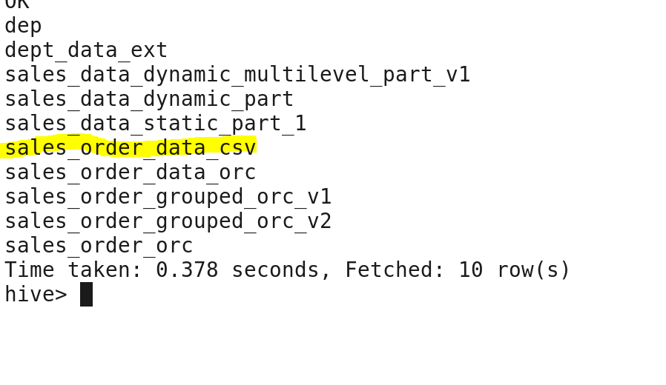

Q4) Load data from hdfs path into "sales_order_csv"

Load data inpath “/datasets/sales_order_data.csv” into table sales_order_data_csv

Output - :



Q5) Load data from "sales_order_csv" into "sales_order_orc"

ANS)

* create table sales_order_orc stored as orc as select * from sales_order_data_csv;

output - :

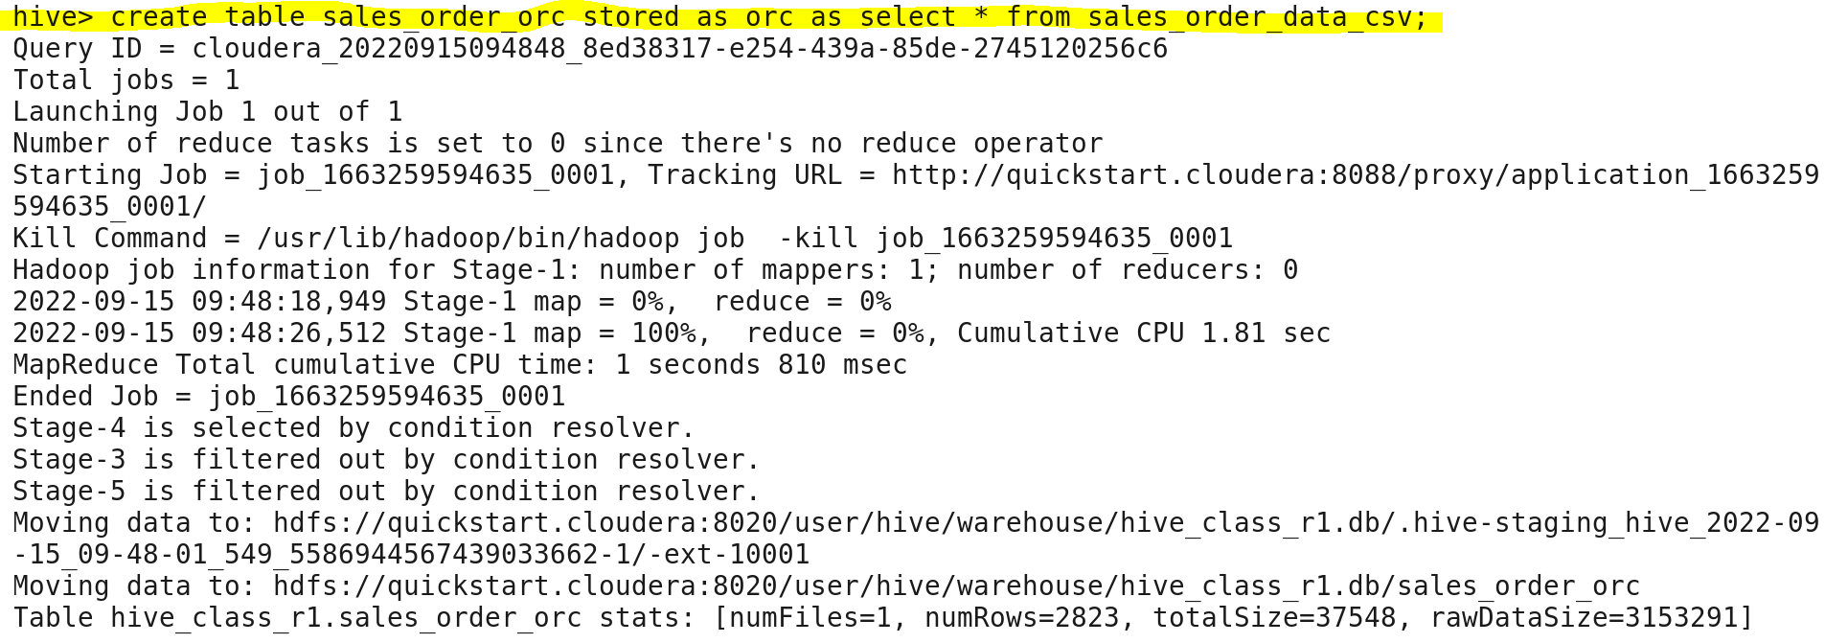

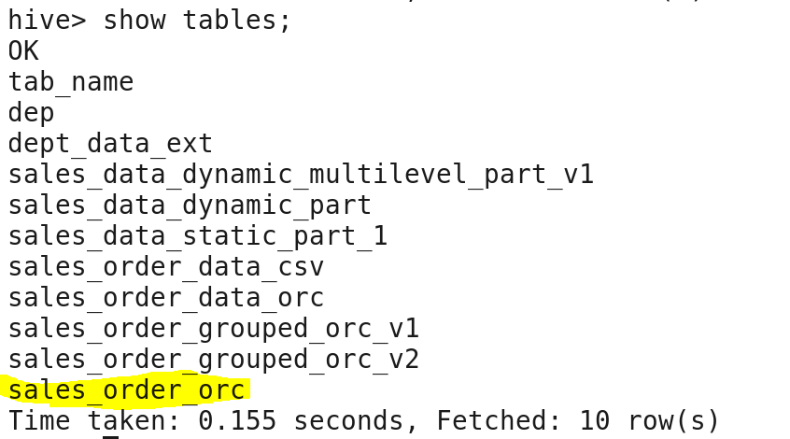

Q6) Load data from "sales_order_csv" into "sales_order_orc"

* from sales_order_data_csv insert overwrite table sales_order_data_orc;
* Perform below menioned queries on "sales_order_orc" table :

1. Calculate total sales per year

Ans)

* Select sum(sales) as total_sales ,year_id from sales_order_orc
* Group by year_id;

Output - :

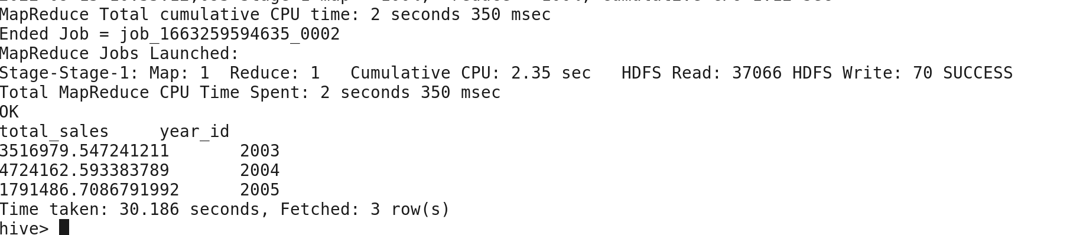

1. Find a product for which maximum orders were placed

Ans)

* select product_line,max(quantity_ordered) as max_order from sales_order_data_orc
* group by product_line
* order by max_order desc
* limit 1;

Output - :

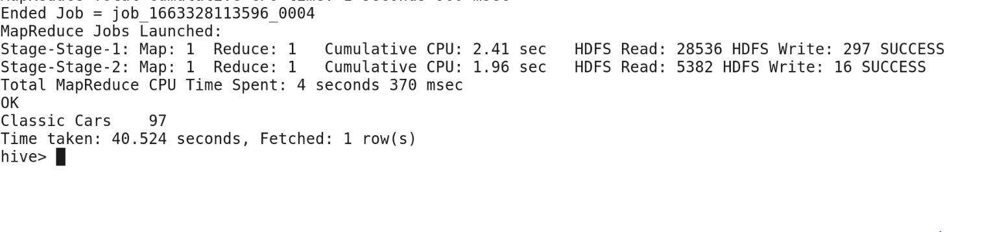

1. Calculate the total sales for each quarter

Ans)

* select qtr_id, sum(sales) as total_sales from sales_order_data_orc
* group by qtr_id;

Output - :

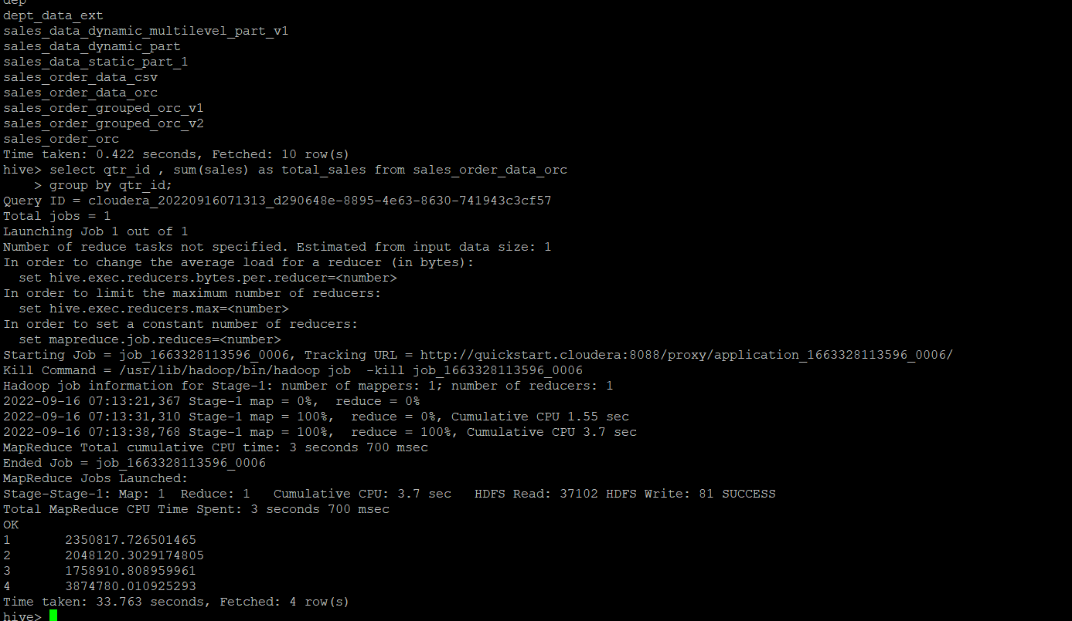

1. In which quarter sales was minimum

Ans ) select qtr_id, min(sales) as min_sales from sales_order_data_csv

Group by qtr_id

Order by min_sales

Limit 1;

Output-:

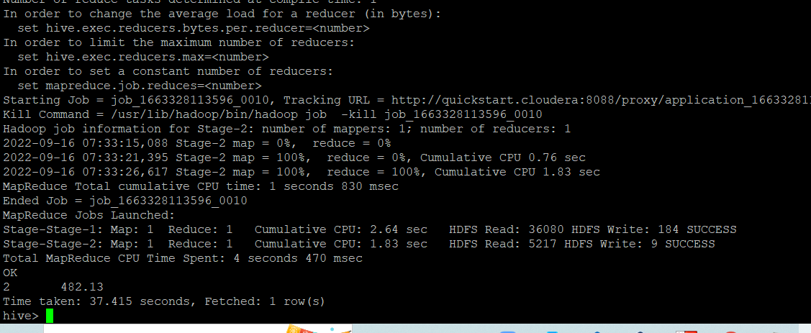

1. In which country sales was maximum and in which country sales was minimum

Ans )

select country, min(sales) as max_sales,max(sales) as max_sales from sales_order_data_orc

group by country;

Output - :

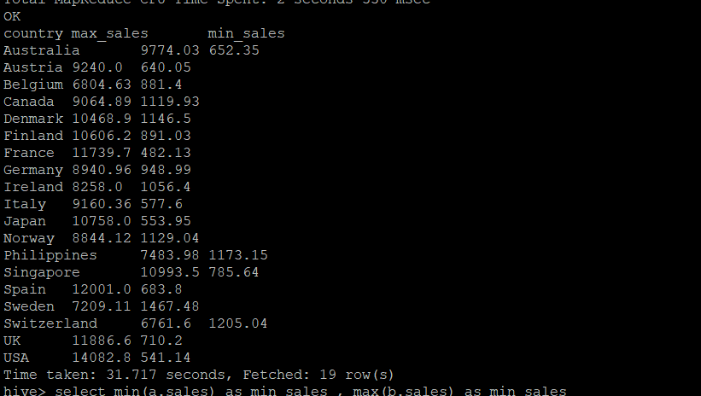

1. Calculate quarterly sales for each city

Ans)

* Select qtr_id,country,sum(sales) as sales from sales_order_data_orc
* Group by qtr_id , country

Output - :

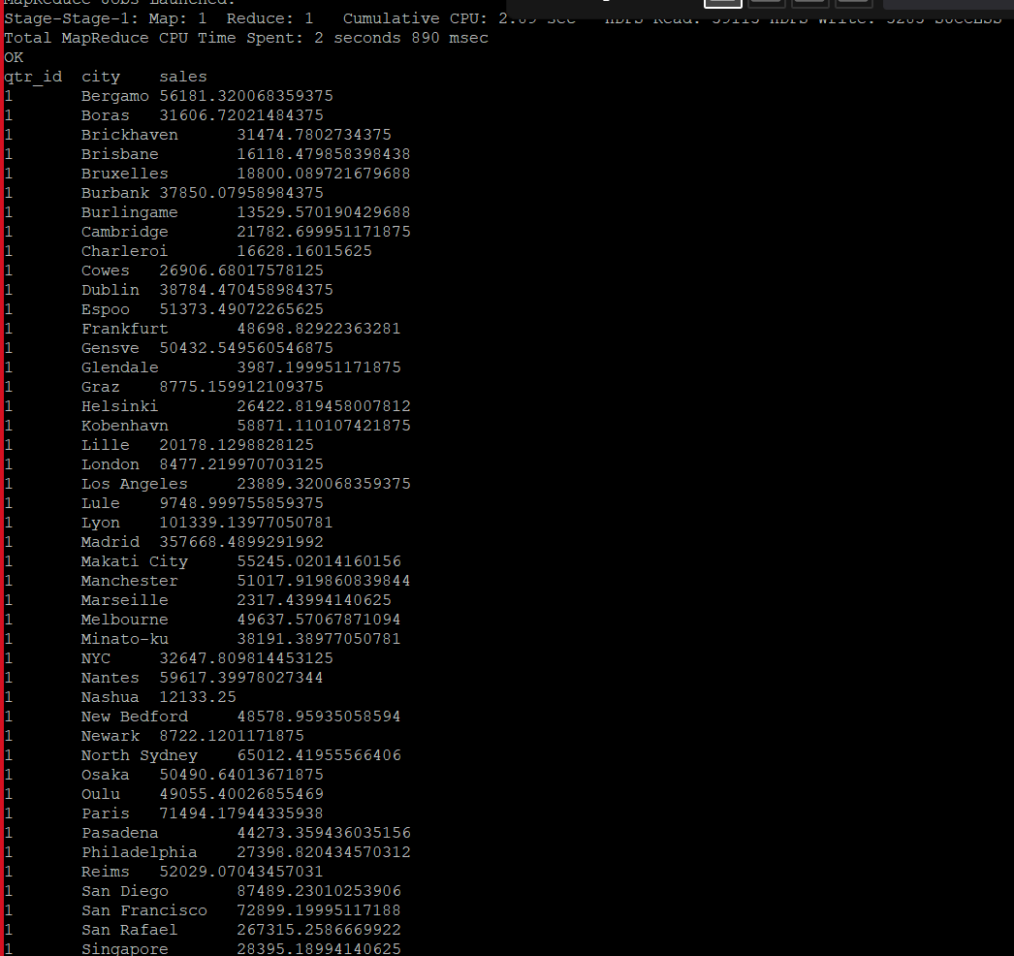

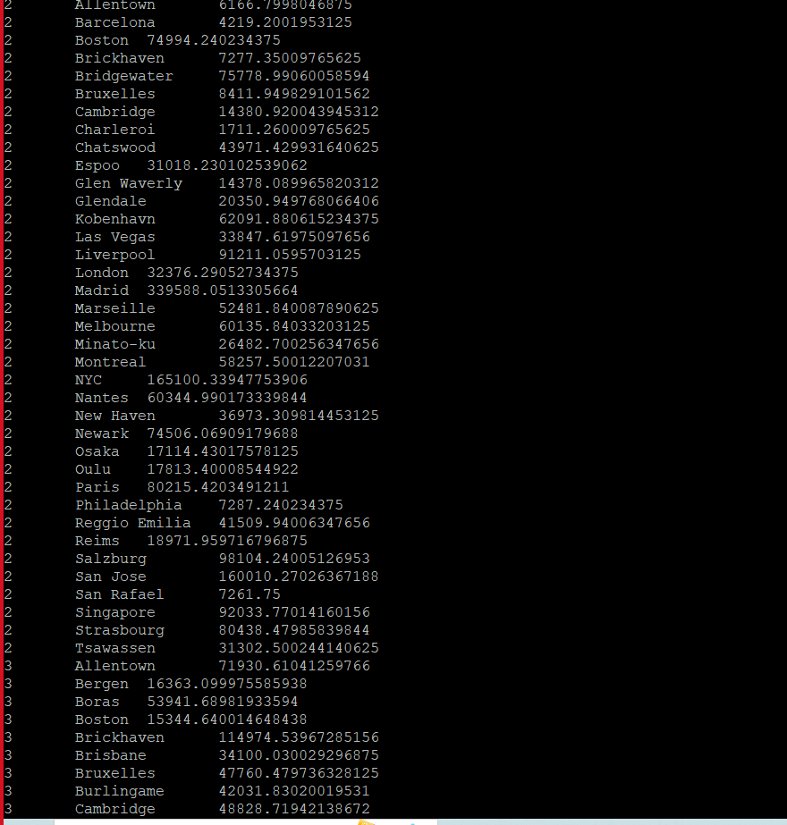

1. Find a month for each year in which maximum number of quantities were sold

Ans)

* select year_id,month_id,max(quantity_ordered) as quantity_sold from sales_order_data_orc group by year_id,month_id;

Output - :

